***Institute of Computer Technology***

***B. Tech. Computer Science and Engineering***

***Sub: ESFP – I***

***Assignment-1***

***Date of Submission:10-11-2022***

***Name: Patel Ayush Padminkumar***

***Branch: Cyber security***

***Enrolment no: CS 32 batch-13***

***Answer the following questions:***

***1. What are Tokens? Explain various kinds of tokens in c programming language?***

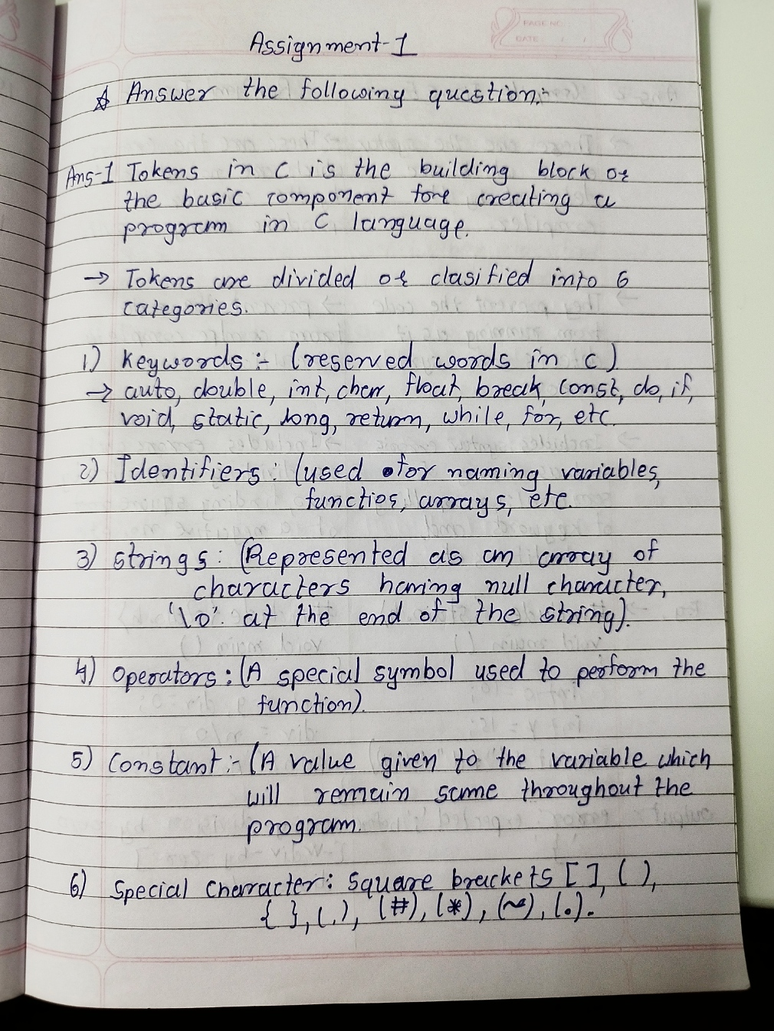

***2. Explain the differences between compile time and run time errors with the help examples?***

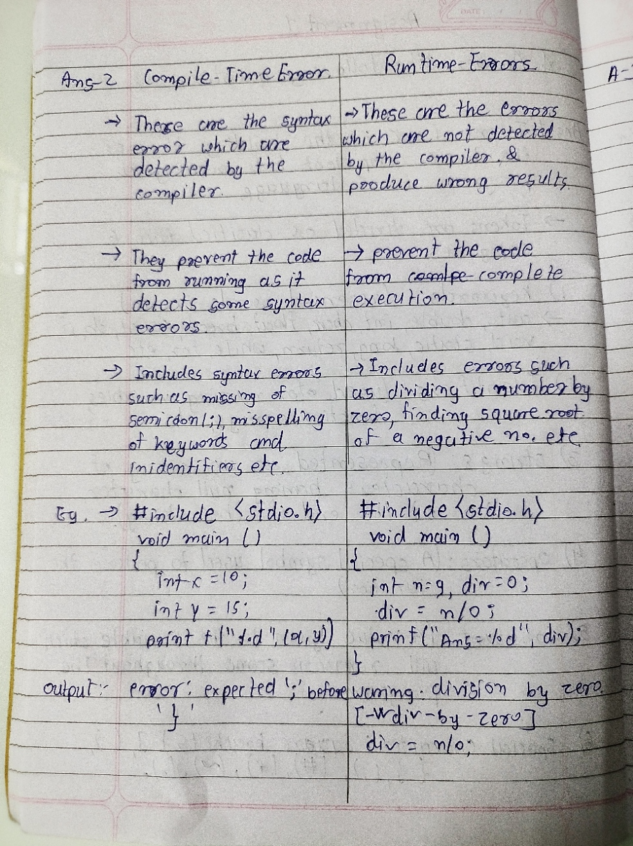

***3. Explain different types of data types in C with a suitable program example.***

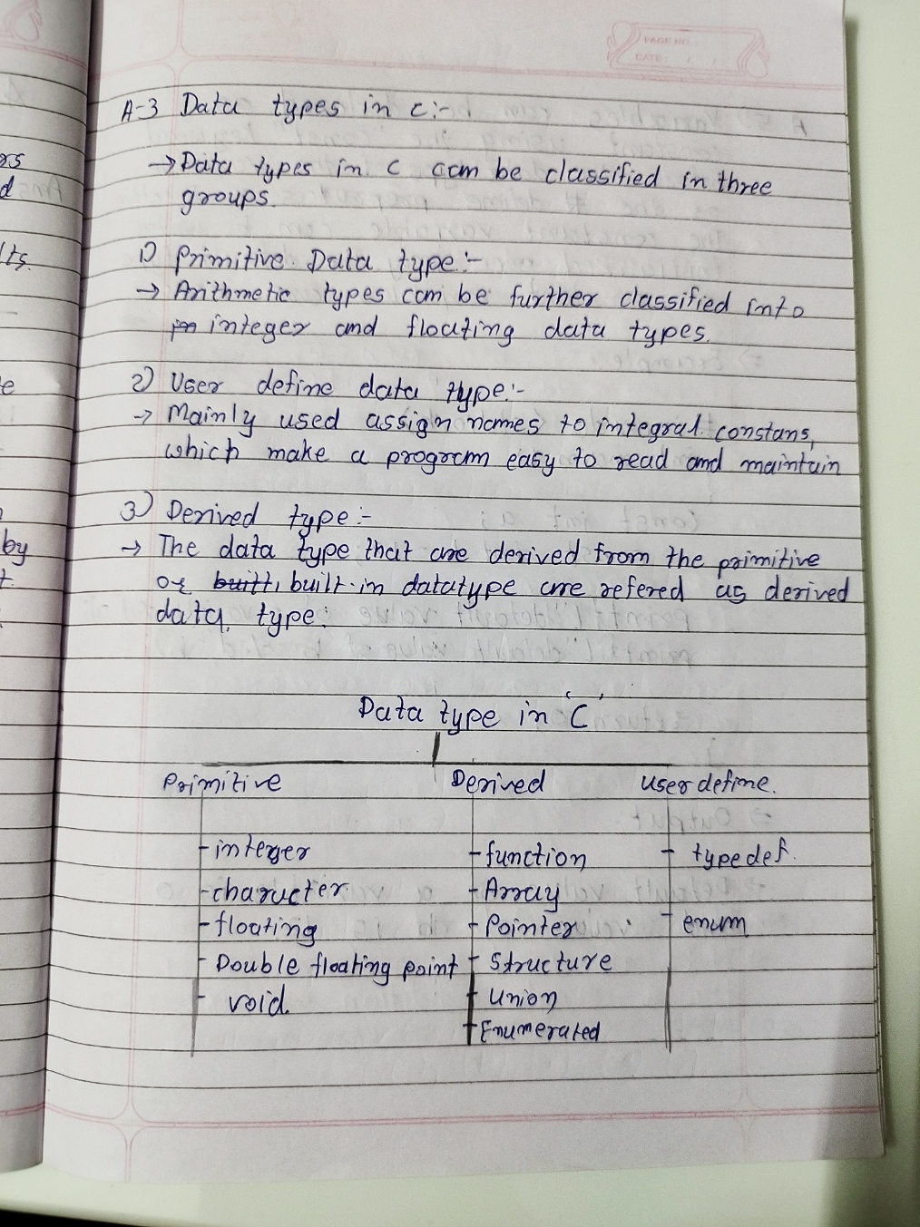

***4. Which variables below are syntactically correct?***

✓ Num_var

✓ 1a

✓ float

✓ sum’s

✓ var1 var2

✓ v2

✓ r.no

✓ i

Ans:

* Num_var
* var1 var2
* v2
* i

***5. What will happen if a variable is declared as constant? Give a program example for constant variable declaration.***

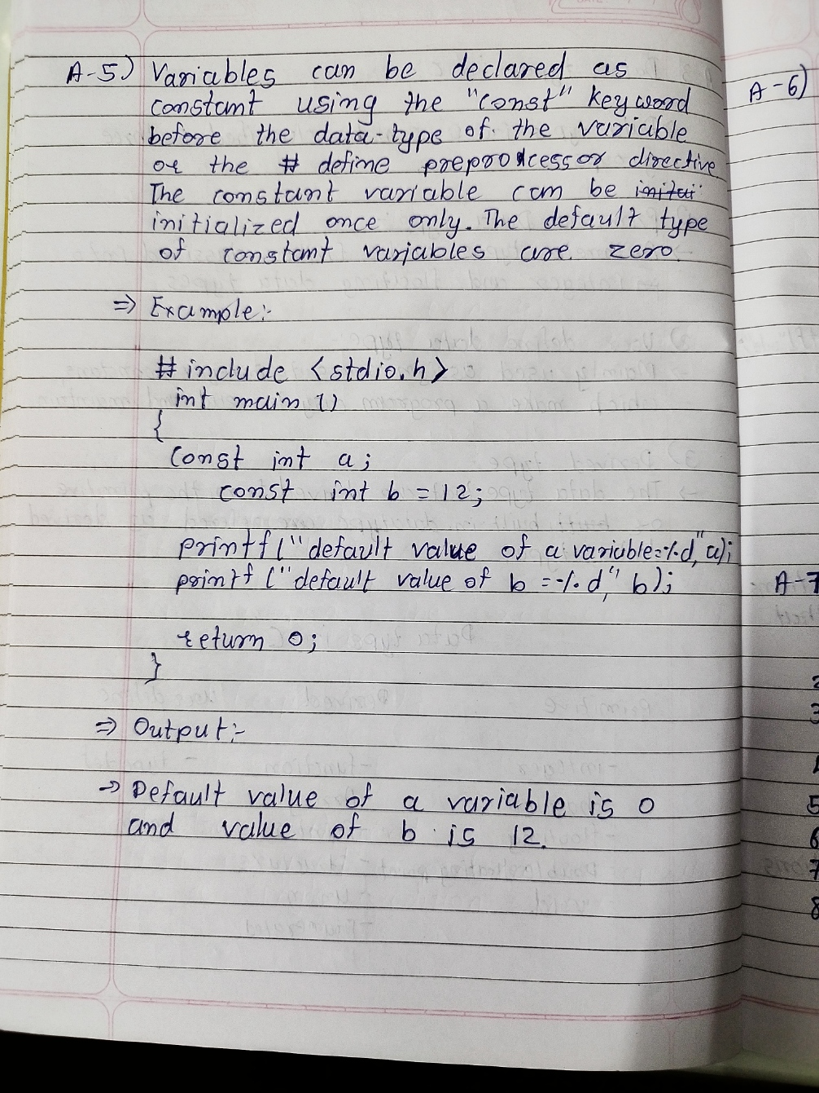

***6. Write an algorithm that allows for the input of a character value, prints its ascii code and displays***

***whether it is alphabet or digit?***

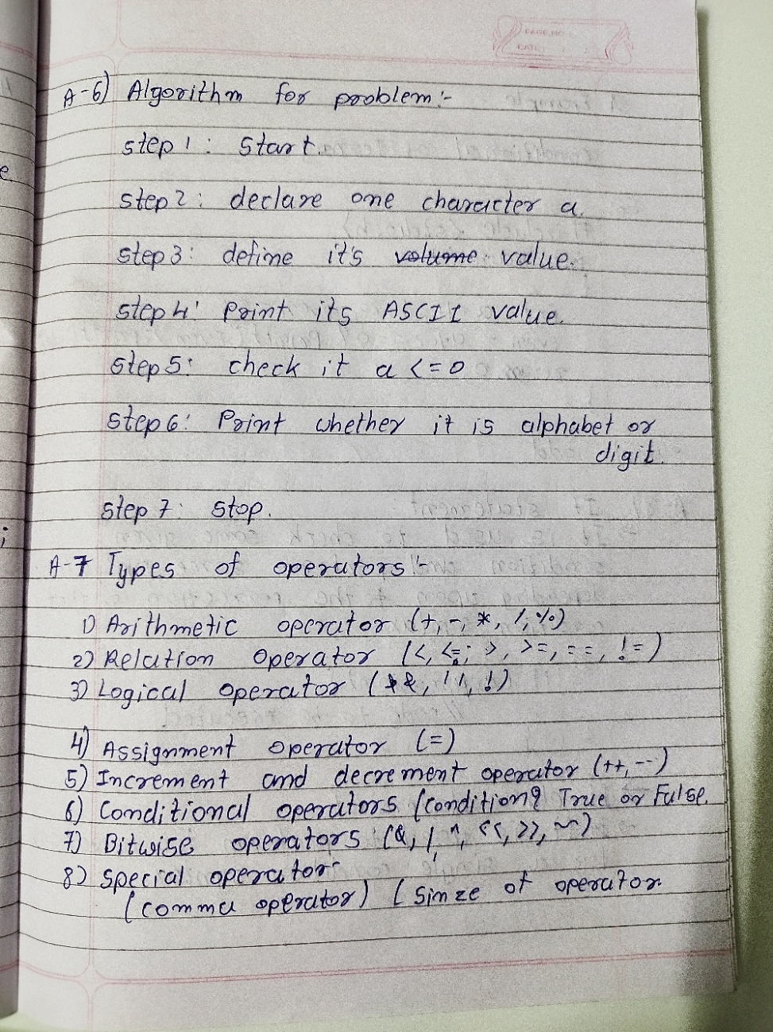

***7. Explain different types of operators in C with suitable program examples?***



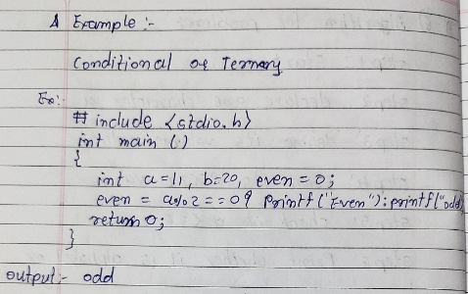

***8. Explain the concept if, if – else, nested if – else and else if ladder condition in c with the help of***

***program example.***

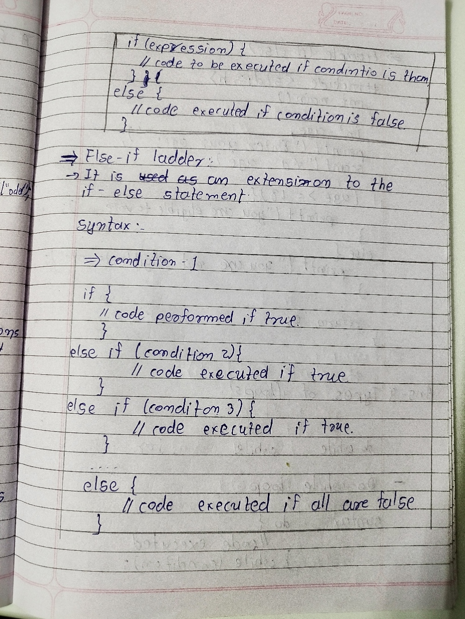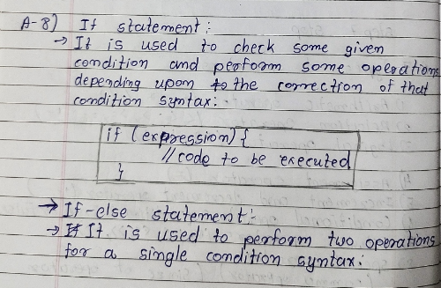

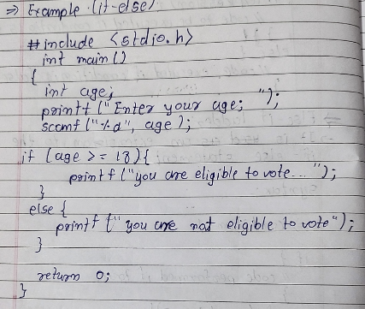

***9. What are the classifications of loops? Explain with the help of syntax, flowchart, and suitable***

***program examples?***

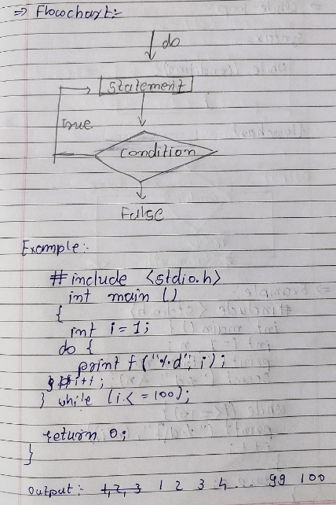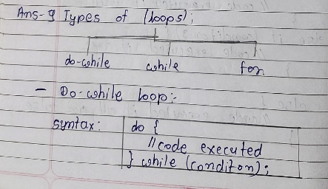

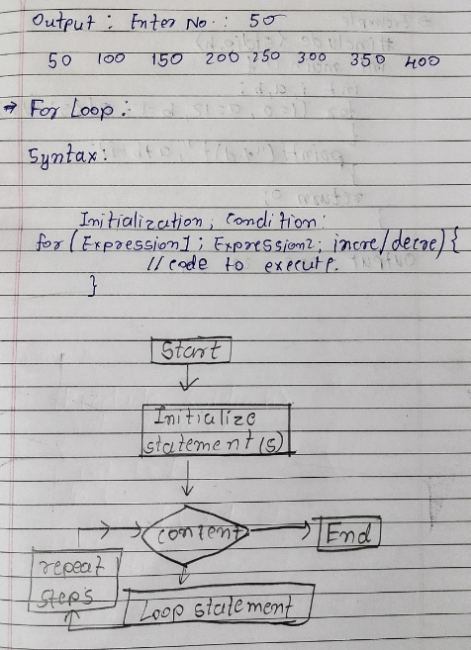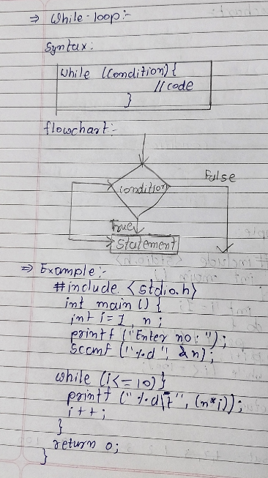

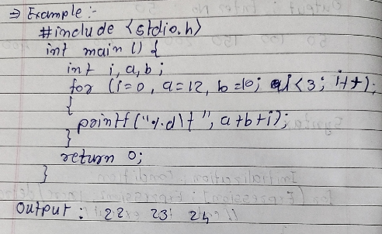

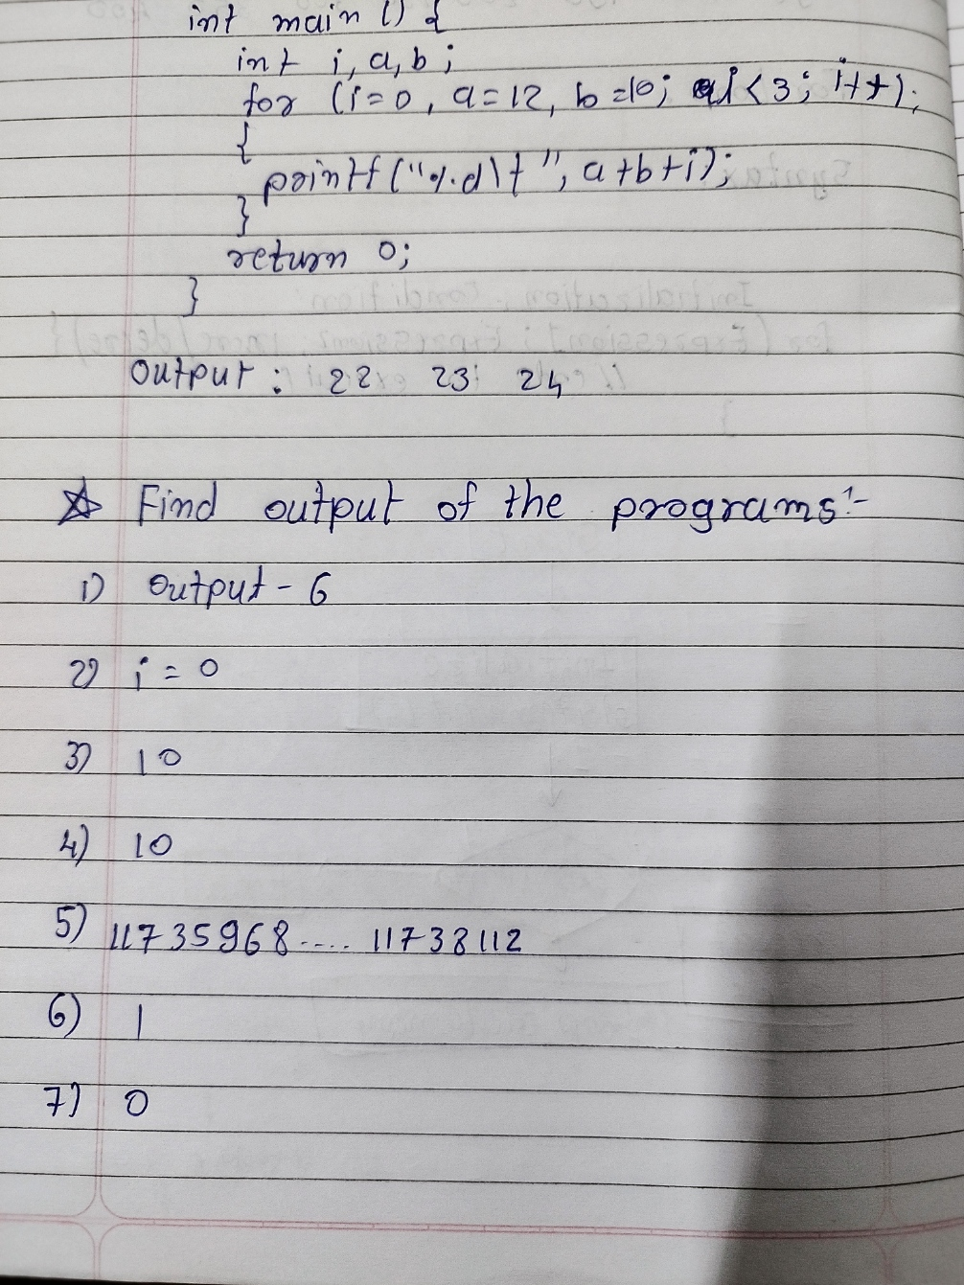

***1. Make a C program to check least among three integers using Ternary Operator?***

***Code:***

#include <stdio.h>

int main()

{

int num1,num2,num3;

printf("enter your number:");

scanf("%d %d %d",&num1,&num2,&num3);

int temp=((num1<num2)? num1:num2);

int result=num3<temp?num3:temp;

printf("\n The Smallest number is %d ",result);

return 0;

}

***Output:***

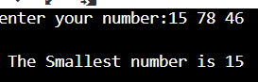

***2. Make a C Program to find whether a number is: -***

***a) Perfect Number.***

***b) Prime Number***

***c) Even or Odd.***

***Code: A) perfect number***

#include <stdio.h>

int main()

{

int n;

printf("Enter the number: ");

scanf("%d",&n);

int sum = 0;

for(int i = 1; i < (n-1); i++)

{

if((n%i)==0){

sum=sum+i;

}

}

if(sum==n){

printf("\n%d is perfect number",n);

}

return 0;

}

***Output:***

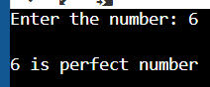

***Code: B) Prime number***

#include <stdio.h>

int main()

{

int n;

printf("Enter the number: ");

scanf("%d",&n);

int count = 0;

for(int i = 2; i < n; i++)

{

if(n % i == 0)

count++;

}

if(count == 0)

{

printf("%d is a prime number.", n);

}

return 0;

}

***Output:***

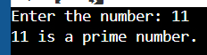

***Code: Even or Odd***

#include <stdio.h>

int main()

{

int num,i,flag=1;

printf("enter your number:");

scanf("%d",&num);

if(num%2==0){

printf("Number is even");

}

else{

printf("Number is odd");

}

return 0;

}

***Output:***

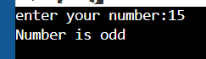

***3. Make a program in C to accept monthly electricity consumed unit from user. Find out total monthly electricity charge of a customer as per below given condition.***

***Criteria of unit charge electricity:***

***Unit (1 to 100) = Rs. 5 (per unit)***

***Unit (101 to 200) = Rs. 10 (per unit)***

***Unit (201 to 300) = Rs. 15(per unit)***

***Unit (>300) = Rs. 20(per unit)***

***Tax: 5% of electricity charge.***

***So, Total electricity charge will be = total unit bill + Tax.***

***Code:***

#include <stdio.h>

int main()

{

int unit;

float amt,total_amt,tax;

scanf("%d",&unit);

if(unit<=100){

amt=unit*5;

}

else if(unit<=200){

amt=500+((unit-100)*10);

}

else if(unit<=300){

amt=1500+((unit-200)*15);

}

else{

amt=3000+((unit-300)*20);

}

tax=amt*0.05;

total_amt=amt+tax;

printf("Electricity Bill = Rs. %.2f", total_amt);

return 0;

}

***Output:***

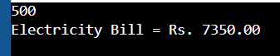

***4. Make a program in C to accept basic salary from user. Find out net salary of an employee as per following condition***

***DA: 12% of Basic salary***

***HRA: 30% of Basic salary***

***Others: Rs.1000 (monthly fix)***

***PF :12% of Basic salary***

***Gross Salary: (Basic Salary + DA + HRA) - PF***

***MA: 5% of basic salary***

***Net Salary = Gross Salary – MA***

***Code:***

#include <stdio.h>

int main()

{

float bs,da,hra,pf,gs,ma,ns;

printf("Basic Salary:");

scanf("%f",&bs);

da=(0.12*bs);

hra=(0.30*bs);

pf=0.12*bs;

gs=(bs+da+hra)-pf;

ma=(0.05*bs);

ns=gs-ma;

printf("DA: %.2f",da);

printf("\nHRA: %.2f",hra);

printf("\nothers= RS. 1000(monthly fix)");

printf("\nPF: %.2f",pf);

printf("\nGross Salary: %.2f",gs);

printf("\nMA:%f",ma);

printf("\nNet Salary= %.2f",ns);

return 0;

}

***Output:***

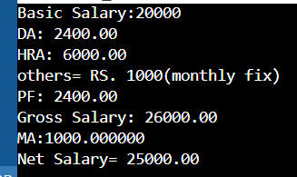

***5. Make a program in C to accept one five-digit number from user. Find out multiplication and addition***

***of alternate digit.***

***input: 56789***

***output:***

***multiplication=315***

***addition = 21***

***Code:***

#include<stdio.h>

int main(){

int num,arr[5],i,j,add=0,multi=1,count;

printf("Enter a Number: ");

scanf("%d",&num);

count=num;

for(i=4;i>=0;i--)

{

arr[i]=count%10;

count=(count-arr[i])/10;

if(i%2==0)

{

add = add + arr[i];

multi = multi * arr[i];

}

}

printf("\nAddition of odd digits is: %d",add);

printf("\nMultiplication of odd digits is: %d",multi);

return 0;

}

***Output:***

